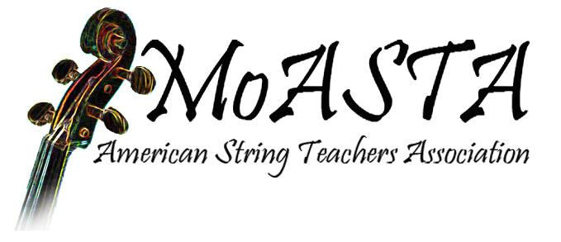
MMEA Board Report
August 9, 2021
- MoASTA’s executive board members next year beginning June 1: Allison Ross, Independence, is president; David Tourtellot, Kansas City, is president-elect; Andy Johnston, Springfield, is past-president; and the Treasurer’s office is temporarily vacant.
- MoASTA board members will work closely with next year’s ASO conductor to ensure that the tempos given when planning the program are the same as the tempos performed, and that there is no extended speaking to the audience or milking for applause and ovations.

Andy Johnston
MOASTA President

