Advancing Music Education Report—Aaron T. Wacker, chair

- Music In Our Schools Month Proclamation went through! Thanks to Marvin Manring for leading this effort.
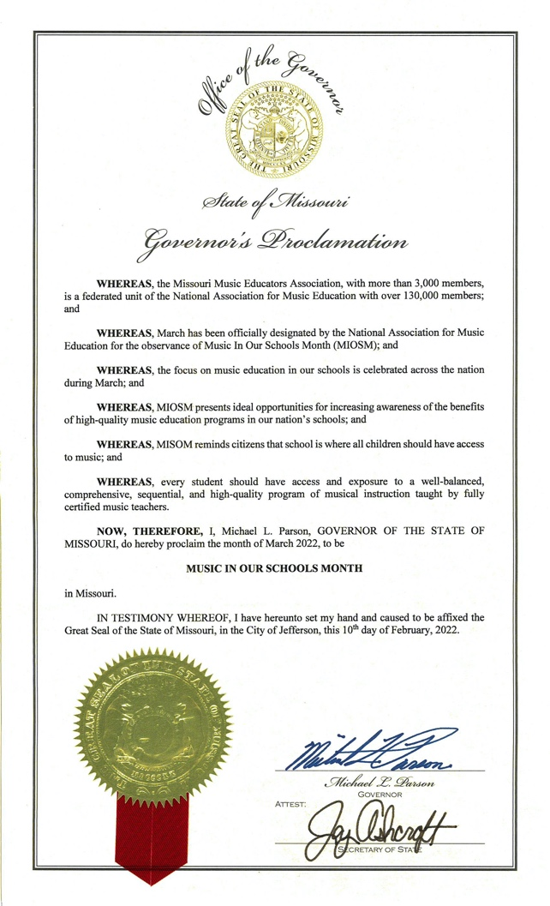

- 2022 Advocacy Day
  - First in-person event since 2019!
  - 2022 Talking Points (see end of the report).
  - Approximately 150 participants.
    - 4 ensembles performed outside on the South Steps of the Capitol Building
    - Universities brought music education students
      - Each school was recognized on the Senate Floor.
      - Students met individual or in small group with legislators
  - Photos from Advocacy Day
  - All-in-all, a very successful day. We are excited to reflect on positives and find areas to improve for the 2023 Advocacy Day

MMEA Music Advocacy
April 2022

Fully Fund The School Foundation Formula and Transportation Fund

Music and arts education have far reaching benefits for students and citizens of Missouri. When appropriation levels for education diminish, the delivery of services diminish, and school Fine Arts programs often suffer from these budget cuts. By fully funding the school foundation formula and transportation, fine arts programs are less endangered.

Legislative request: MMEA encourages the Missouri Legislature to fully fund the Missouri Public Schools Foundation Formula and Transportation Fund.

Accessibility to Music in Schools

Accessibility: School day accessibility to music education programs should be increased across the state. MMEA believes that arts education is essential and recommends that the Missouri State Board of Education supports comprehensive sequential music instruction in elementary, middle and high schools.

Key Points:
- a minimum of 50 minutes of instruction per week for music in all elementary schools
- a minimum of 4 hours per week of fine arts instruction in middle schools to be taught to all students
- a one-credit fine arts graduation requirement in all high schools
- that all courses are taught by fully certified music specialists

Rationale: Music Education has a positive impact on learning. That impact is reduced exponentially when programs are reduced and treated like an afterthought.

Legislative Request: As part of a well-rounded education for all students we ask that a sequential, standards-based music education remain part of the core curriculum for all students.

Charter Schools

MMEA believes that all charter schools should be consistent with all public schools, and provide students with a comprehensive education, including access to sequential, standards-based music education taught by instructors fully certified in music education.

Key Points:
- Charter students deserve a full and balanced educational experience that includes music
- Charter schools are part of the American educational landscape and should be encouraged to incorporate all core academic subjects in a substantive way

Legislative Request: In order to ensure that all students receive a comprehensive education including sequential, standards-based music education as part of the core curriculum we ask that Legislators require charter schools be consistent with public schools in regard to music art curriculums.

Teacher Career Plan

The shortage of fully certified teachers has had a significant impact on music education in Missouri. We understand that this concern has many contributing factors. Salary is a significant factor in teacher attrition. Therefore, MMEA supports HB 2493 Teacher Career Plan, and its increase in funding of salary supplements and the two-year eligibility requirement for such an increase.

MMEA also supports HB 2799, changes to PSRS rules concerning working after retirement. We are in favor of the retiree use of the critical shortage provision of four years and the three-year waiver of the 550/50% earning limits.

