Selected Ensemble Verification Form

List by ensemble identification (not by school name)

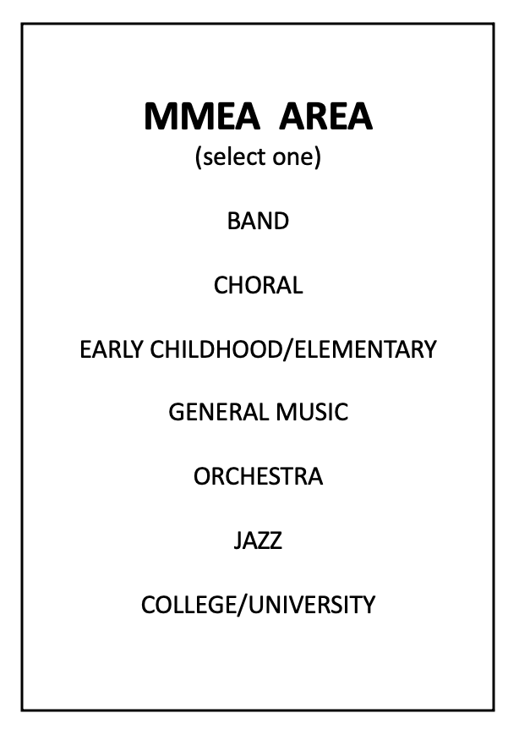
*Select and place the top-rated ensemble in the number 1 slot. No further ranking is necessary.

- *___________________________________________

- ____________________________________________

- ____________________________________________

- ____________________________________________

- ____________________________________________

- ____________________________________________

- ____________________________________________

- ____________________________________________

- ____________________________________________

- ____________________________________________

HS Alternate: ____________________________ Elementary/GM Alternate

MS/JH Alternate: _________________________

University Alternate: Small Ensemble Alternate

Panelist Signature: ______________________________________________

Panelist Signature: ______________________________________________

Panelist Signature: ______________________________________________

