Policies & Procedures

Part III

Performing Ensemble Selection

Revised and Approved by Board of Directors: April, 2022

Performing Ensemble Selection

Objective: Missouri Music Educators Association promotes the highest possible standard of excellence in performance. The Missouri Music Educators Association, in its annual In-Service Workshop/Conference, highlights the outstanding work done by music educators and their students throughout Missouri. In selecting the honor ensembles, every effort is made to select from the wide diversity of school size and classification from within our state.

PERFORMING ENSEMBLE SELECTION GUIDELINES

- RECOMMENDATION PANEL:

- The Recommendation Panel must be comprised of out-of-state music educators with little to no Missouri connections. The Panel must meet outside the state of Missouri. Every effort will be made for an in-person Recommendation Panel. If an in-person option is not possible, a synchronous virtual option is available.

- The Recommendation Panel must have three members. Members of the Panel must be specialists in the area to be evaluated. It is recommended that there be wide representation including Panelists from, but not limited to, the following areas: elementary, general music, middle school, high school, collegiate level, small school, large school, rural and urban schools. Jazz must include at least one vocal jazz specialist. Every effort will be made to ensure the Panel is representative of the MMEA membership in regard to its diversities.

- Names of the Panel members shall not be revealed to anyone other than the MMEA President, the MMEA Executive Director, and the MMEA Executive Secretary. Panel members should be instructed to remain anonymous by not revealing their participation in a Recommendation Panel.

- Recommendation Panel information must be submitted to the MMEA President no later than May 15.

- SELECTION PROCESS:

- Deadline for submission of application materials is June 1.

- Evaluation materials will be distributed to each person on the Recommendation Panel prior to the evaluation process.

- Performance evaluations must be blind. The identity of applicants (names of schools and/or directors) must remain anonymous to the Recommendation Panel.

- Every effort will be made to ensure the ensembles are representative of the MMEA membership in regard to its diversities.

- Audition recordings must meet all requirements as stated in the “MMEA Performance Criteria.”

- Evaluation of audition recordings by the Recommendation Panels will take place during the month of June.

- Confidential notification of selected ensembles will be sent electronically to the President and the Executive Director no later than July 1.

- Application materials will be ground mailed to the President as soon as possible after the evaluation process has concluded.

- Vice-Presidents will submit compensation/reimbursement forms online on the day of the Recommendation Panel meeting and will ground mail receipts to the Secretary/Treasurer as soon as possible after the evaluation process has concluded.

- Verification of ensemble and director eligibility will be made by the President and the Executive Director.

- Final acceptance and the “Official Invitation to Perform” at the MMEA Conference will be extended by the MMEA President only.

- Notification of acceptance to the ensemble directors will occur no earlier than July 15 and no later than August 1.

COMPENSATION/REIMBURSEMENT

- One meal will be provided for each member who attends an in-person Recommendation Panel.

- For Panels hearing 10 or fewer ensembles, the honorarium is $50.00 per person. For Panels hearing 11-30 ensembles, the honorarium is $100 per person. Panels hearing 31 or more ensembles will receive an honorarium of $150 per person.

- MMEA will reimburse expenses for the respective Vice-President according to the guidelines outlined in the MMEA Travel Policy.

- Each Vice-President must complete the Request for Payment/Reimbursement Form through the MMEA Website on behalf of each Panelist.

TIMELINE: GENERAL
- February 1 Website programming revisions complete & ready for testing
- February Testing of online application form
- April 1 Activate online application and reference materials
- April VP acknowledgement of applications received & accuracy (ongoing)
- April Electronic reminders to membership
- April Online application database updates to MMEA area VP’s
- April VP acknowledgement of applications received & accuracy (ongoing)
- May 15 Recommendation Panel information submitted online
- May Electronic reminders to membership
- May Online application database updates to MMEA area VP’s
- May VP acknowledgement of applications received & accuracy (ongoing)
- May Preparation of Recommendation Panel materials
- June 1 Application Deadline
- June 2 Online Registration Form closes
- June 2 Online application database (final) to MMEA area VP’s
- June Review/selection of performance applications
- June Recommendation Panel expenses reimbursed
- July 1 Deadline: Ensemble selection information to MMEA President and
MMEA Executive Director
- July 10 Selection results to MMEA Executive Director for director
eligibility verification
- July 10 Selection results to MMEA VP’s for verification of accuracy
- July 15 Announcement of performing ensembles may begin
- July 20 Return (ground mail) application materials to directors
- August 1 Deadline to announce performing ensembles
- August Compile notes for needed revisions to selection process
- December Provide necessary website revisions to Caledon Virtual

TIMELINE:
- April 1 Activate online application and reference materials
- April VP acknowledgement of applications received & accuracy
(ongoing)
- April Electronic reminders to membership
- April Online application database updates to MMEA area VP’s
- April VP acknowledgement of applications received & accuracy
(ongoing)
- May 15 Recommendation Panel information submitted online
- May Electronic reminders to membership
- May Online application database updates to MMEA area VP’s
- May VP acknowledgement of applications received & accuracy
(ongoing)
- May Preparation of Recommendation Panel materials
- June 1 Performance Application Deadline
- June 2 Online Registration Form closes
- June 2 Online application database (final) to MMEA area VP’s
- June Review/selection of performance applications
- June 4-6 Prepare for Recommendation Panel meeting
- June 7-19 Recommendation Panel meeting window
- June 20 Deadline: Ensemble selection information to MMEA President and
MMEA Executive Director for director eligibility verification
- June 22 Ground mail application materials to MMEA President (if needed)
- June Recommendation Panel expenses reimbursed
- June 25 Selection results to MMEA VP’s for verification of accuracy
- July 15 Announcement of performing ensembles may begin (President)
- July 20 Return (ground mail) application materials to directors (President)
- August 1 Deadline to announce performing ensembles
- August Compile notes for needed revisions to selection process

Development of Guidelines for Ensemble Auditions

- Upon submission, directors will receive an electronic confirmation.
- VP’s are responsible for preparing Panelists’ Packets

- Panelist Packet provided for each Panelist should include:

  - Cover sheet with general audition instructions (Recommendation Panel instructions)
  - A listing of ensembles and repertoire in audition order.
    - Panelists should use this to make personal notes and impressions for later decision making.
    - Each ensemble should be assigned identification. (Class 4 - #6)
Note: This identification should be established before the audition and indicated on the application. Panelists are not to know the identity of any of the ensembles.
A separate evaluation form must be used for each ensemble.

    - Evaluation forms should only include necessary critique of the ensemble, not a rank order or reference to other groups.
  - Reimbursement form for the Panelist fee (in-person meeting)
  - Possibly a menu to make lunch selections (in-person meeting)

Selection Process
June 1 Application Window Closes
June 4-6 VP’s prepare Panelists Packets
June 7-19 VP’s send packets to Panelists allowing at least one week for adjudication. Panelists
fill out the evaluation form for each ensemble and fill out the preliminary ranking
form. At the Recommendation Panel meeting, the panel will use their preliminary
ranking form to create the final selection of ensembles, relistening to ensembles
if necessary.
June 20 VP submits final selected ensemble list to President and Executive Director.

- Selected Ensemble Verification Form

  - Fill out form at the end of the audition process
  - Indicate top rated ensemble and include alternates as indicated on form
  - Have Panelists sign sheet
  - Return verification form with audition applications to MMEA President

MMEA Recommendation Panel Instructions

On behalf of the Missouri Music Educators Association, thank you for taking time from your busy schedule to serve the students and teachers of Missouri through this ensemble selection process.

Objective: MMEA promotes the highest possible standard of excellence in performance. The Missouri Music Educators Association, in its annual In-Service Workshop/Conference, highlights the outstanding work done by music educators and their students throughout Missouri. In selecting the honor ensembles, Every effort will be made to ensure the ensembles are representative of the MMEA membership in regards to its diversities.

*The identity of Recommendation Panelists is known only by the area Vice-President, MMEA President, and MMEA Executive Director. The Vice-President and Panelists shall not discuss any details of the listening process to anyone but the President and Executive Director. Thank you for helping us ensure that the names of Panelists, location, and specifics of this process remain confidential.

*For General Music, Elementary and Small Ensemble, please listen to recordings in the order presented. For Orchestra, Band, Choir, and Jazz, listen to the recordings beginning with middle school, then high school grouped from smallest school classification to the largest (1A, 2A, 3A, 4A, 5A), concluding with College/University and Community Ensembles.

*A representative sample, identified by the Panelist, of each track must be evaluated in order to appropriately complete the evaluation form.

* Before each ensemble’s tracks are played, be sure to have the Ensemble Identification listed correctly on the Performing Ensemble Evaluation Form.

*As you listen, please write constructive comments in each area of the Performing Ensemble Evaluation Form.

*Your completed Performing Ensemble Evaluation Forms will eventually be distributed to the primary conductor of the ensemble. Thank you in advance for affirming MMEA’s belief that whether an ensemble is selected or not, this process should serve as a learning tool.

* When you have finished evaluating recordings in a category (i.e middle school, or 2A), use the Preliminary Ranking Form to rank those ensembles that achieved conference quality, up to a maximum of six ensembles. The full Panel will then convene and compile a group ranking. That group ranking sheet will be submitted to the MMEA Vice-President at the conclusion of the full Panel session.

* At the conclusion of the evaluation process, the Panel will discuss and select the overall top-rated ensemble, then fill the remaining ensemble spots keeping in mind that every effort will be made to ensure the ensembles are representative of the MMEA membership in regards to its diversities.

* Finally, an Elementary, General Music, High School, Middle School, and University alternate will be listed (provided that one is available) on the form.

MMEA Recommendation Panel Preliminary Ranking Form
For use by all Recommendation Panels.

The full Panel will agree on a group ranking to be listed below. With each category, begin by comparing individual notes and rankings. In the process of deliberation, the Panel may choose to mute and listen to specific recordings again individually before reconvening the discussion. At the conclusion of the listening process, this ranking form will be utilized by the Panel to determine the final list of ensembles selected, and will be submitted to the MMEA Vice-President at the conclusion of the listening session.

MMEA Area (please circle): Orchestra Band Choir Jazz General Music Elementary

Middle School/General Music/Elementary

- __________________________

- __________________________

- __________________________

- __________________________

- __________________________

- __________________________

Class 1

- __________________________

- __________________________

- __________________________

- __________________________

- __________________________

- __________________________

Class 2

- __________________________

- __________________________

- __________________________

- __________________________

- __________________________

- __________________________

Class 3

- __________________________

- __________________________

- __________________________

- __________________________

- __________________________

- __________________________

Class 4

- __________________________

- __________________________

- __________________________

- __________________________

- __________________________

- __________________________

Class 5

- __________________________

- __________________________

- __________________________

- __________________________

- __________________________

- __________________________

College/University

- __________________________

- __________________________

- __________________________

- __________________________

- __________________________

- __________________________

Small Ensemble (Band Only)

1.____________________________

2. ____________________________

3. ____________________________

4._____________________________

5._____________________________

6._____________________________

Selected Ensemble Verification Form

List by ensemble identification (not by school name)

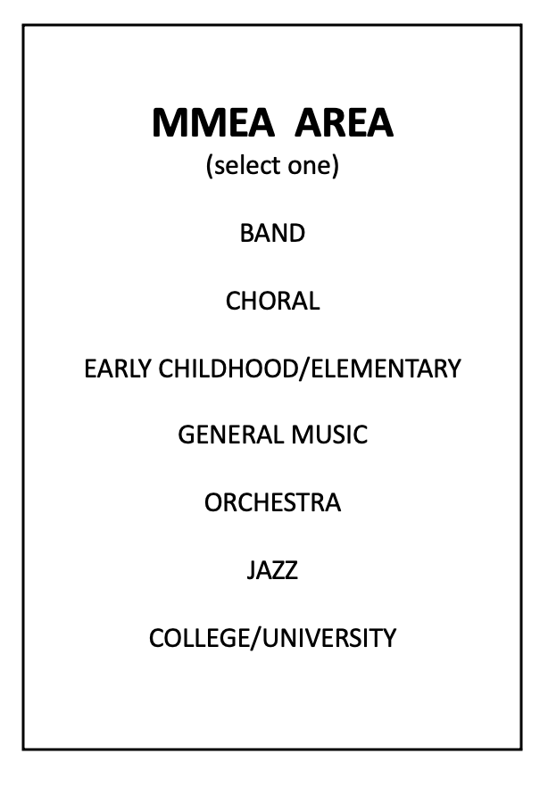
*Select and place the top-rated ensemble in the number 1 slot. No further ranking is necessary.

- *___________________________________________

- ____________________________________________

- ____________________________________________

- ____________________________________________

- ____________________________________________

- ____________________________________________

- ____________________________________________

- ____________________________________________

- ____________________________________________

- ____________________________________________

HS Alternate: ____________________________ Small Ensemble or Elementary/General Alternate

MS/JH Alternate: _________________________ 1. ____________________________________

University Alternate: ______________________ 2. ____________________________________

Panelist Signature: ______________________________________________

Panelist Signature: ______________________________________________

Panelist Signature: ______________________________________________

Vice-President Checklist

PREPARATION

❑ Select/Confirm Recommendation Panel
❑ Select/Confirm Location/Date
❑ Confirm Receipt of Applications
❑ Prepare Panelist’s Packets
❑ Confirm A/V Equipment/Wi-Fi Availability
❑ Confirm all details with Panelists
❑ Final Reminder to Panelists

PROCESS

❑ Assign Application Numbers (must be anonymous)
❑ Collate all Application and Evaluation Forms
❑ Email all Recommendations/Selections to MMEA President June 28
❑ Mail all applications, administrative, and panelist materials to the MMEA President

❑ Ensemble Evaluation Forms
❑ Recommended Ensemble Verification Form (VP keeps a copy)
❑ Hard copy of Database and Notes (VP keeps a copy)
❑ Recommendation Panel Expense Report Submitted

FOLLOW-UP

❑ Confirm receipt of materials with MMEA President
❑ Confirm Final Selections with MMEA President
❑ Proof Ensemble Performance Schedule (as completed by MMEA President)

Performing Ensemble Evaluation Form
Selections marked in each category of the evaluation form may NOT be cumulative to final selection.

Recommendation Panelists shall remain anonymous. Comments included on this form are intended to assist the evaluators in the recommendation process. NO SCORES or other selection information shall appear on the form. Evaluation forms will be returned to the ensemble director for review.

Ensemble Identification: _______

Panelist, please use check marks for this section:
NOTE: Selections marked in each category of the evaluation form may NOT be cumulative to final selection.

 | Consistently | Frequently | Occasionally | Rarely
Tone Quality
Clarity, Consistency, Control, Focus
Intonation
Accuracy, Consistency
Rhythm
Accuracy of Notes, Rests, Meters, Duration, Tempo
Balance/Blend
Ensemble Awareness
Technique
Attacks, Releases, Control, Mechanical Skill
Interpretation/Expression
Dynamics, Phrasing, Style, Artistry, Authenticity, Performance Practice
Diction -Vocal
Bowing - Strings
Articulation - Winds
Execution - Percussion
Choice of Literature
Variety, Diversity, Breadth, Compilation

Panelist, please use check marks for this section to indicate area(s) of strength:

 | Tone Quality | Intonation | Rhythm | Balance/  Blend | Technique | Interpretation/  Expression | Diction, Bowing, Articulation, Execution | Choice of Literature
Strengths

Clarifying comments for above evaluation (Use back of page if necessary):

