2022 MMEA Application for Performance
Website Instructions

- Login to the MMEA Leadership Hub.
  - From MMEA Homepage, select “About MMEA”
  - Scroll to the bottom of the page and select “MMEA Administrative Resources”
  - Login with the Password “mmeabod2224.”
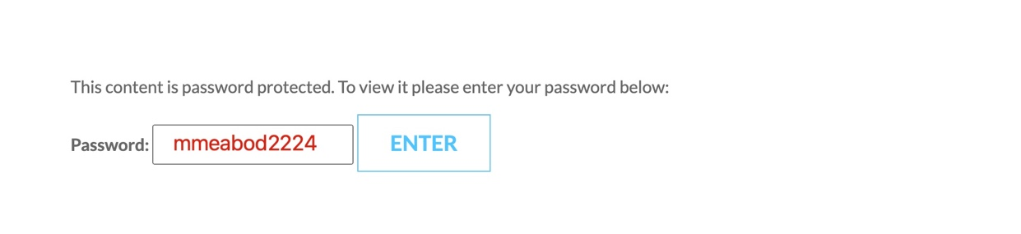

- Select your Leadership Page.
- Select “Performing Ensemble Selection Administration.”
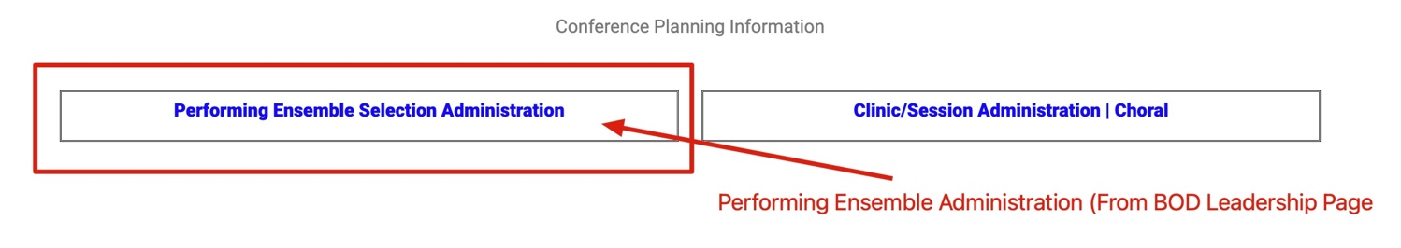
  - Located at the bottom of the leadership page.

- Review the revised Policies & Procedures for Application for Performance.

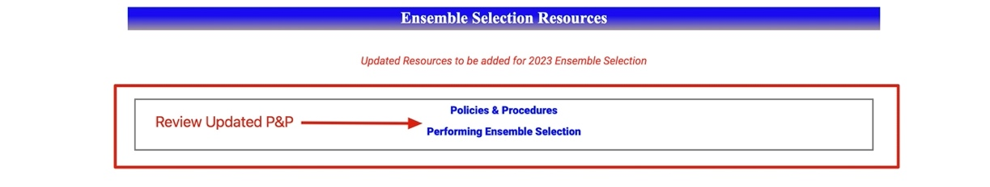

Next Page
- Review the deadlines for completing the application review/selection process.
- Select your VP tab.
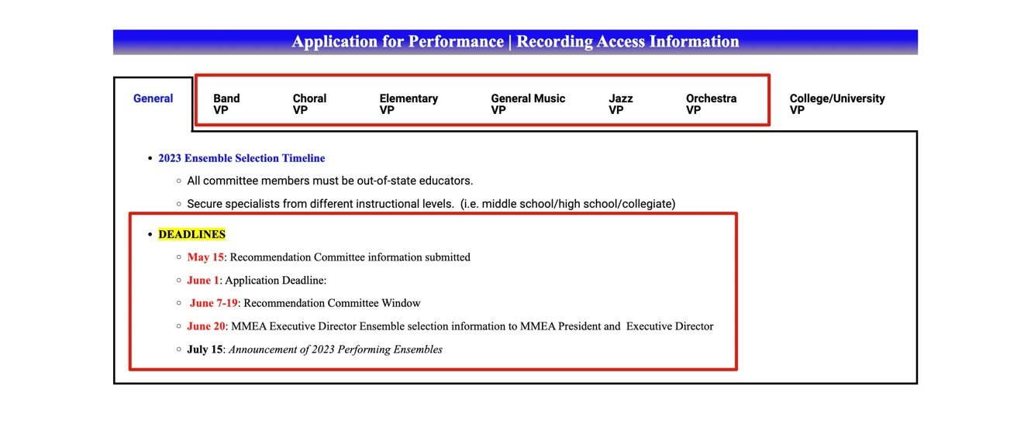

- Access your VP Dashboard to access application information and recordings.
  - Use the following URL to access the VP Login Page:
    - https://mmea.net/wp-admin
  - Enter your Username and Password.
    - After login, you will see a “profile page.” From here, enter the URL for the VP Recording Dashboard.
    - VP Recording Dashboard URL: https://mmea.net/admin-dashboard
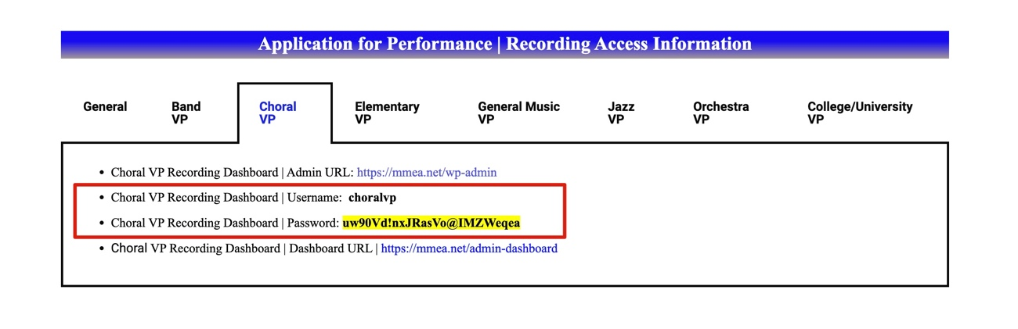

Next Page

- VP Recording Dashboard
  - Sort by Name, School, or Director
  - View application details by selecting "Edit"
  - Download Recordings & Documents by Selecting "View & Edit"
    - IF "Upload" appears, Recordings and/or Documents have not yet been uploaded.
  - PAYMENT: IF "Resend Receipt" appears, the application payment has been received.

