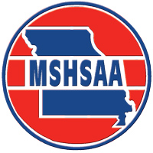
MSHSAA Music Adjudicator Training Session

The MSHSAA will sponsor one music adjudicator training session which will be held in conjunction with the MMEA Conference on Wednesday, January 23, 2019. If you would like to register for this session, simply complete the registration form below and return to MSHSAA.
This session is open to any music educator at no charge. In order to be certified to judge at the MSHSAA Festivals, it is a requirement that the attendees have seven years of teaching experience. Music Educator’s with less than seven years teaching experience are welcome to attend and would likely find the session beneficial. Again, to register, simply complete and return the registration form below.

MSHSAA Music Adjudicator Training Pre-Registration Form
Registration Deadline is January 9, 2019

Name: Click here to enter text. Address: Click here to enter text.

City/State/Zip: Click here to enter text. Home Phone: Click here to enter text.

Business Phone: Click here to enter text. Cell Phone: Click here to enter text.

E-Mail Address: Click here to enter text.

I would like to attend the music adjudicator training session listed below:

Check One: ☐ Instrumental
Time: 12:00 – 4:00 p.m.
Location: Crystal Ballroom

☐ Vocal
Time: 12:00 – 4:00 p.m.
Location: Parasol 2

Return Completed Form to:
Davine Davis
c/o MSHSAA
P.O. Box 1328
Columbia, MO 65205-1328
Fax: 573-875-1450
Email: Email@mshsaa.org

